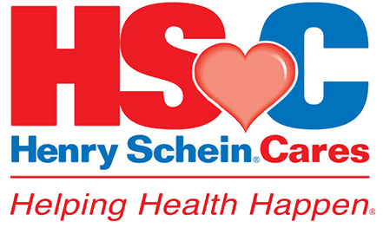
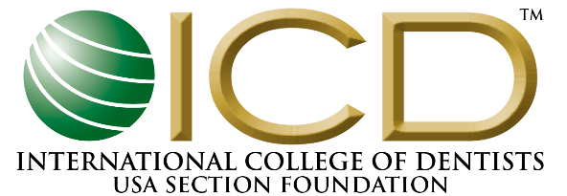
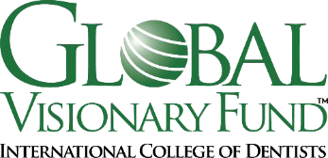

2024 PRODUCT SUPPORT APPLICATION
Please submit your application by email to: icdusafndtgrants@gmail.com

Application Preferences
Projects demonstrating the ability to achieve a sustainable improvement in oral health, overall health, or improved quality of life for the community or populations impacted are most likely to receive support.
Project Name:

Name of Organization Applying:

Contact Person Name/Title: ____________________________________ ICD Member? Yes No

Phone: _______________________________ Email: __________________________________________

Description of project and projected outcome (Provide a running description of the project, specific
aim, methodology, long-term objectives, and benefits):

On-site location and date of project:
On-site Person Responsible for Security of Materials (Name):
Operational plan for project (Describe methods to be used, nature of services to be provided, and the monitoring and reporting of results. Provide names or summary of other dentists, volunteers and/or Fellows participating):

How will the project’s impact be measured?

Plan for getting materials/Equipment to project site:

How will customs charges be managed (if any)?

Who will own any remaining materials or equipment at the conclusion of the project?

How will the ICD Global Visionary Fund and Henry Schein Cares receive public recognition for participating?

List the supplies being requested, including quantities and prices (supplies can be chosen from the Henry Schein online catalogue) – Please note: A Henry Schein account is needed to view pricing.

Item # | Item Name/Description | Quantity | Unit Type | Price Per Unit | Total

Total Fair Market Value of requested supplies: $ US

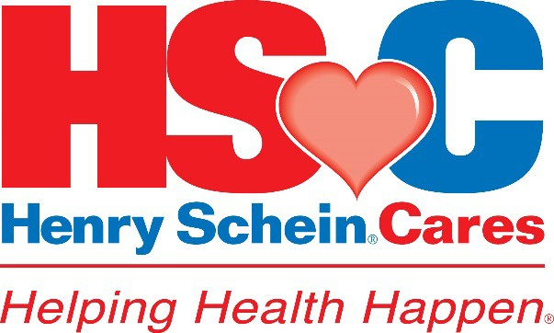

Donation Request Checklist
*Must be submitted with application*

Name:
Title:
Address:
Telephone Number:
Email Address for shipping:
Please check the box if the shipping and grant letter/donation agreement point of contact are the same.

Name:
Title:
Address:
Telephone Number:
Email Address for Grant Letter/Donation Agreement:
Deadline date by which the donation needs to arrive:
Applicant Signature: Date: _____/______/______
*Please note that we require an 8–10-week turnaround time from application receipt to review and process donations.*

Please submit a copy of your IRS determination letter of 501 (c)(3) status
if you are a US-based non-profit organization.

